Task 1

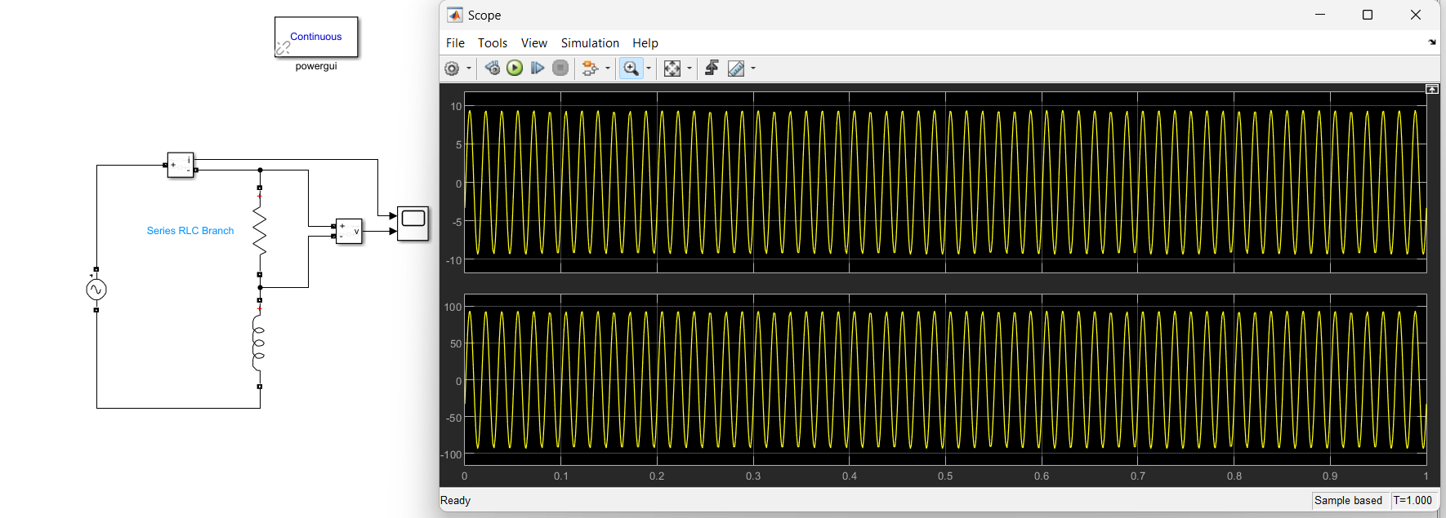

Task 2

Task 3

